Pre-requiesite :

Prerequisites
- cordon Nodes
- Release Notes
  - (API) 1.30 → 1.31
  - extensions/beta1
  - networking
- Downgrade → Fresh installation
- Lower envs
- control plane → Nodes (same version)
  - control plane: 1.30
  - nodes: 1.29 → 1.30
- Cluster Autoscaler
- Five available IP address (subnet)
Plan of action :

Upgradation of cluster in AKS :

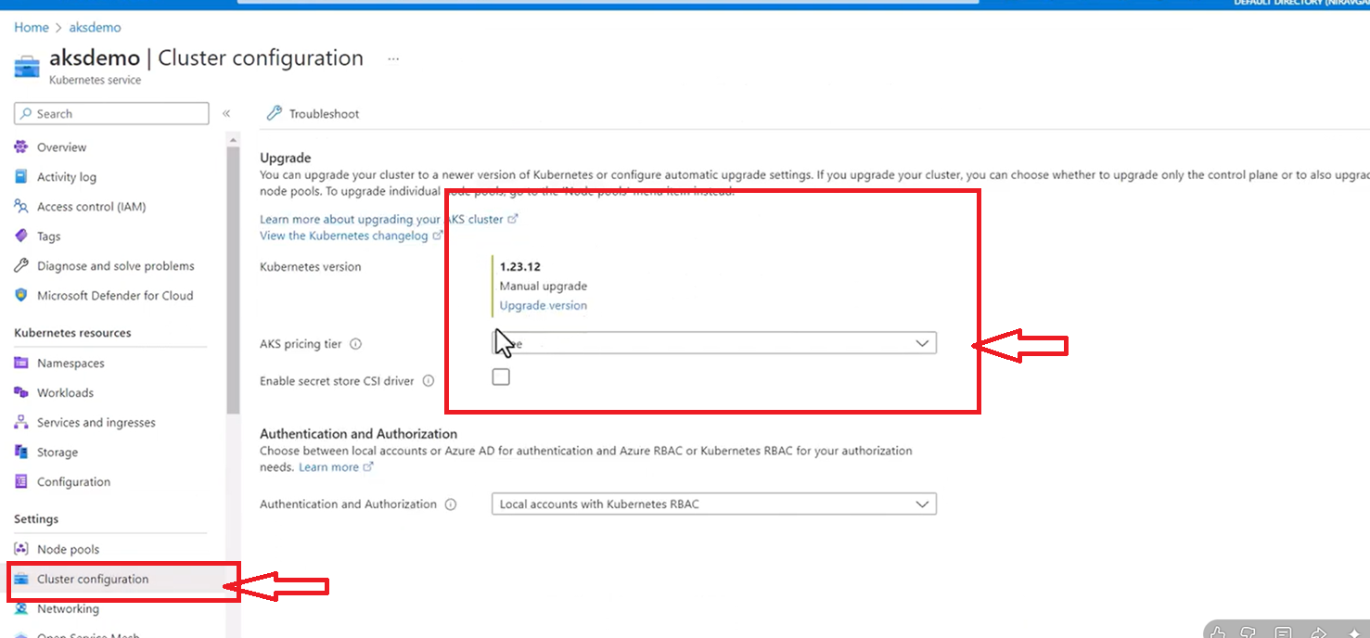

Step _2
Upgrade the majior version updgrade
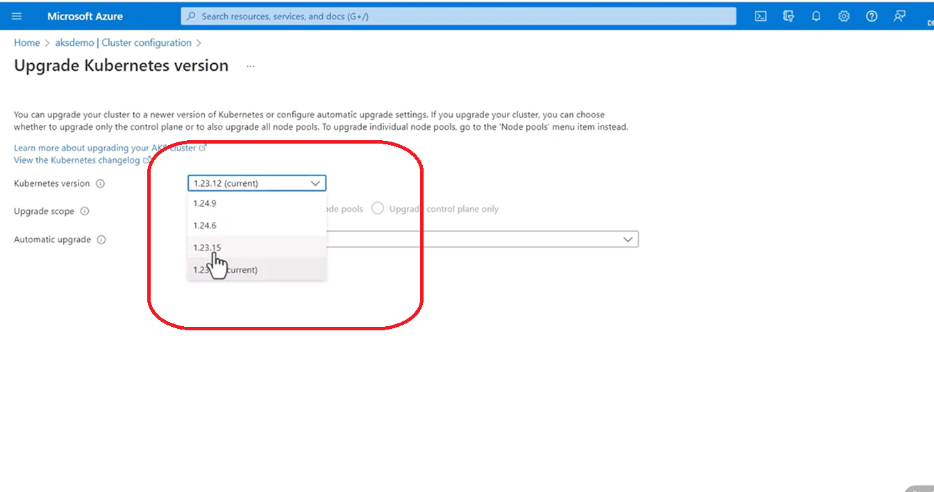
Application Flow goes like that only …
1.34.6 ← 1

1.34.8 ←

1.35.6←2
We can upgrade a major version to major

Step _ 3 : frisrt upgrade contol Plain only

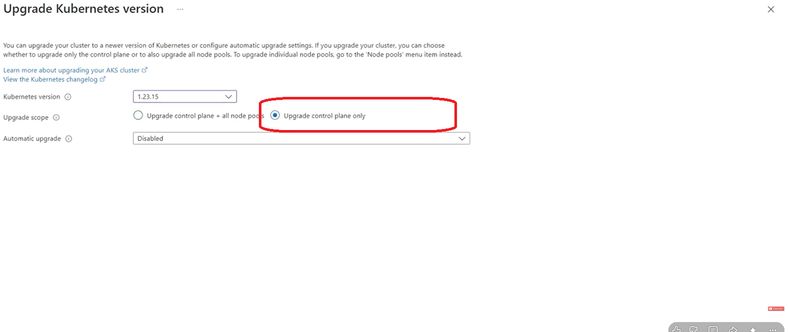

We can cheack Notifications also
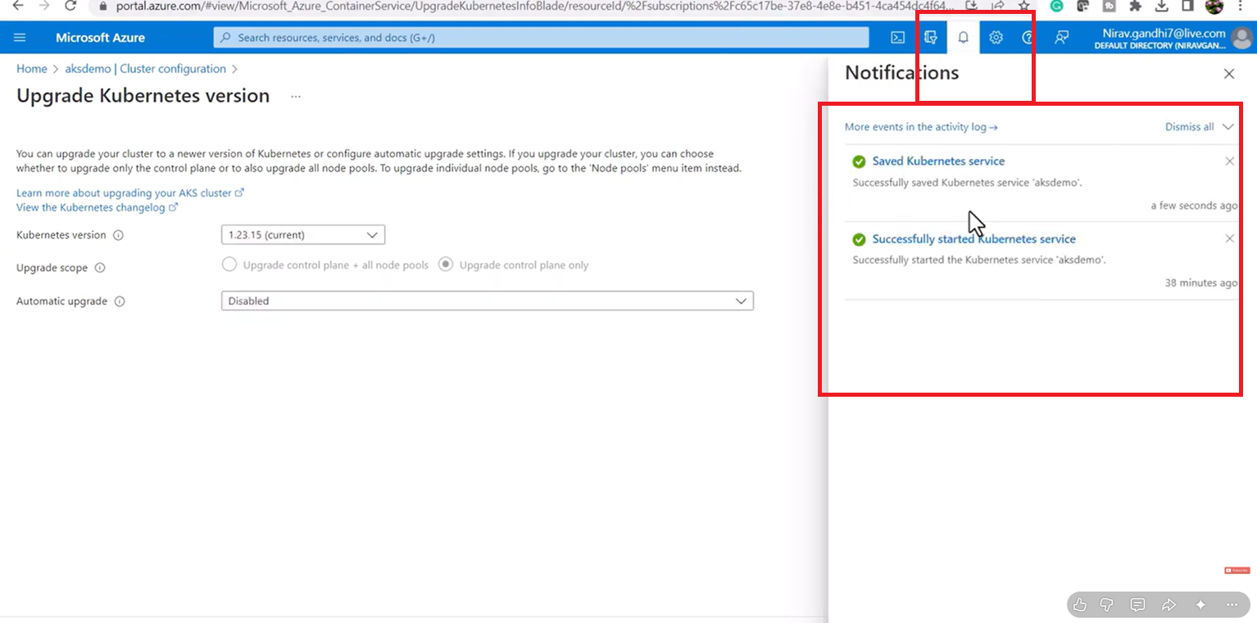
After the Succesfull updgration of contol Plain version
make changes in Node pool also .

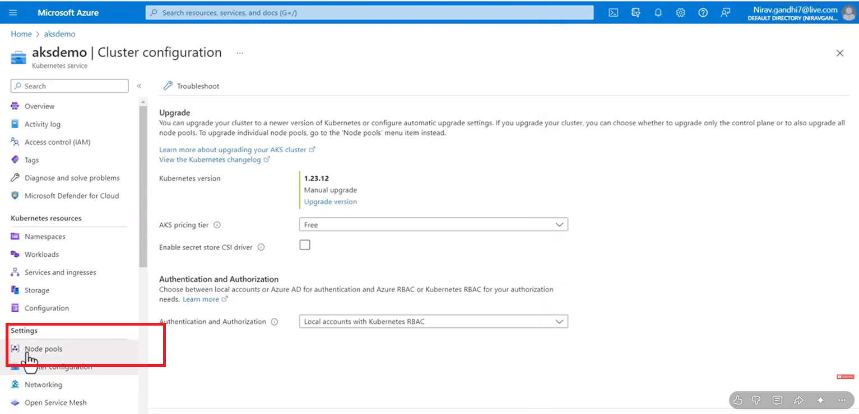
CLik Node Pool :
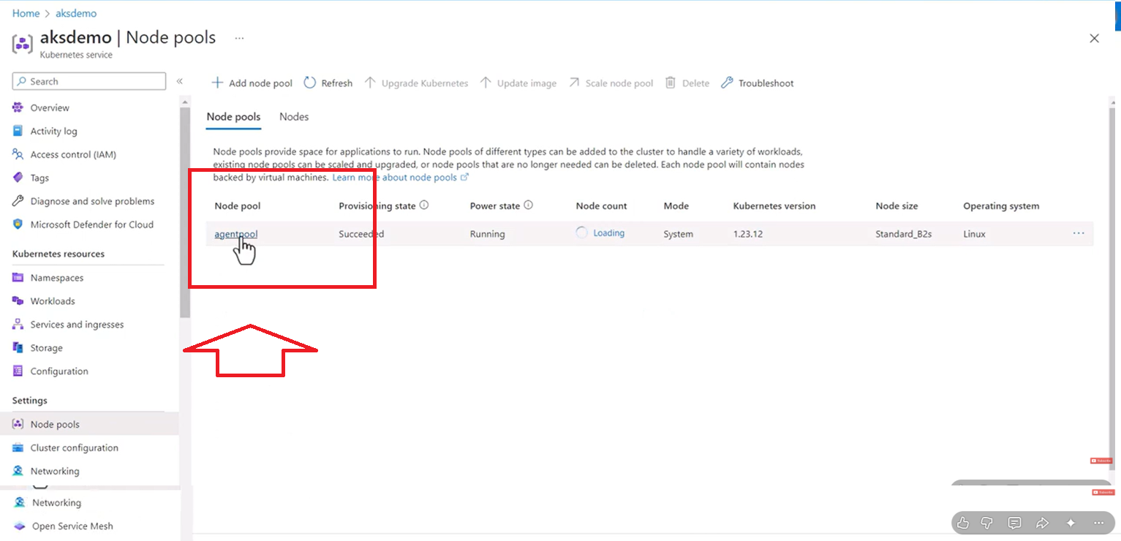
CLIK Nood Mechine Name 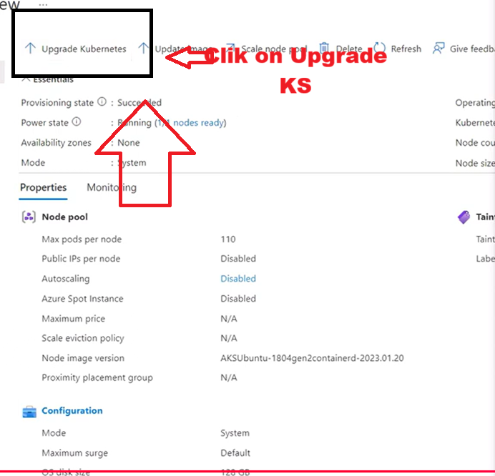

Clik on upgrade K8s

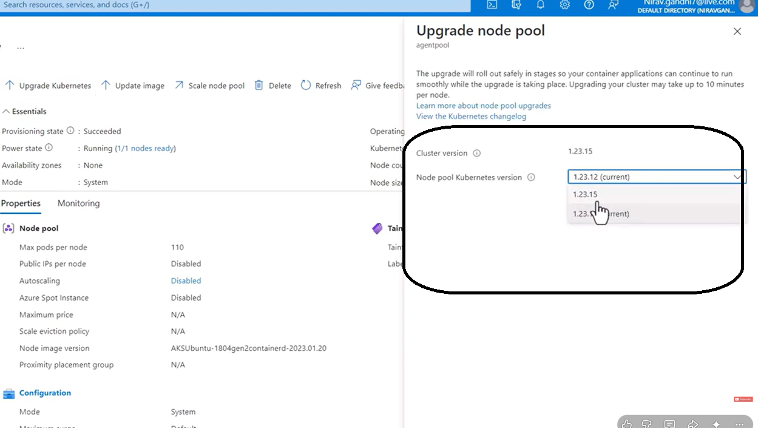

Upgarde this changes

You can connect to kubernates _ Cluster Events also ..
CMD line : kubectl.exe get events

AKS Upgrade
Friday, February 10, 2023 — 9:08 AM

Ref. Link
- https://learn.microsoft.com/en-us/azure/aks/supported-kubernetes-versions?tabs=azure-cli
- https://endoflife.date/azure-kubernetes-service

To find out what versions are currently available for your subscription and region
- az aks get-versions --location eastus --output table
- az aks get-upgrades --resource-group aksdemo --name aksdemo --output table

Pre-Upgrade Planning
- Identified the braking changes using datree
- kubectl.exe get events
We have datree test we also to Schema version changes and depeancies are changes
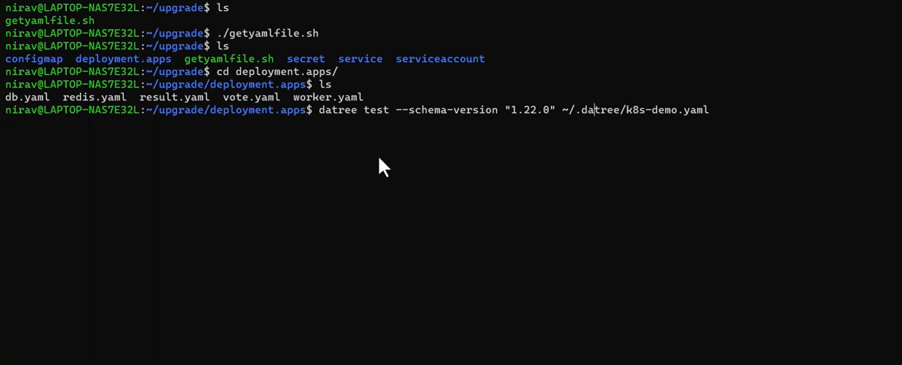
When you upgrade your cluster, the following Kubernetes events may occur on the nodes:
- Surge: Create surge node.
- Drain: Pods are being evicted from the node. Each pod has a 5 minute timeout to complete the eviction.
- Update: Update of a node has succeeded or failed.
- Delete: Delete a surge node.
[!NOTE] You can only upgrade one minor version at a time.
For example, you can upgrade from 1.14.x to 1.15.x, but you cannot upgrade from 1.14.x to 1.16.x directly. To upgrade from 1.14.x to 1.16.x, you must first upgrade from 1.14.x to 1.15.x, then perform another upgrade from 1.15.x to 1.16.x.
Datree _ test
nirav@LAPTOP-NAS7E32L:~/upgrade$ ls
getyamlfile.sh

nirav@LAPTOP-NAS7E32L:~/upgrade$ ./getyamlfile.sh

nirav@LAPTOP-NAS7E32L:~/upgrade$ ls
configmap deployment.apps getyamlfile.sh secret service serviceaccount

nirav@LAPTOP-NAS7E32L:~/upgrade$ cd deployment.apps/

nirav@LAPTOP-NAS7E32L:~/upgrade/deployment.apps$ ls
db.yaml redis.yaml result.yaml vote.yaml worker.yaml

nirav@LAPTOP-NAS7E32L:~/upgrade/deployment.apps$ datree test --schema-version "1.22.0" ~/.datree/k8s-demo.yaml

